
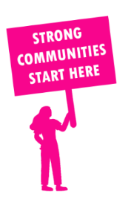
THE VALUE OF NEIGHBOURHOOD HOUSES IN SYDENHAM IN 2024

Neighbourhood Houses are the Hearts of their Communities.
41,088 visits
19 volunteers
19 jobs
Value to the electorate
per $1 of income:
$2.98
Community value provided:
$3,302,344
Here’s what participants reported:
96% said the activity they participated in had a positive or very positive impact on their emotional wellbeing,
98% said the activity they participated in had a positive or very positive impact on their physical wellbeing
95% said the activity they participated in had a positive or very positive impact on their social connections.
52% participants became more involved in community activities outside of a Neighbourhood House
73% said the activity they participated in had a positive or very positive impact on their sense of belonging.

36
community groups supported
3,758
Sessions across 5 Neighbourhood Houses
n/a KGS
in food relief
20
NHCP funded hours/week on average
72
Hours connecting people to gov services

Neighbourhood Houses in Sydenham
Delahey Community Centre
Fraser Rise Children's & Community Centre
Hillside Community Centre
Sydenham Neighbourhood House
Taylors Hill Youth and Community Centre (Unfunded)

