
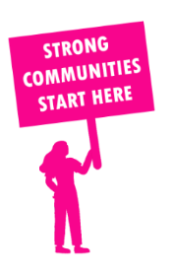
THE VALUE OF NEIGHBOURHOOD HOUSES IN RINGWOOD IN 2024

Neighbourhood Houses are the Hearts of their Communities.
28,596 visits
67 volunteers
53 jobs
Value to the electorate
per $1 of income:
$5.15
Community value provided:
$5,053,152
Here’s what participants reported:
96% said the activity they participated in had a positive or very positive impact on their emotional wellbeing,
97% said the activity they participated in had a positive or very positive impact on their physical wellbeing
95% said the activity they participated in had a positive or very positive impact on their social connections.
50% participants became more involved in community activities outside of a Neighbourhood House
79% said the activity they participated in had a positive or very positive impact on their sense of belonging.

88
community groups supported
4,131
Sessions across 2 Neighbourhood Houses
2,040 KGS
in food relief
25
NHCP funded hours/week on average
96
Hours connecting people to gov services

Neighbourhood Houses in Ringwood
Central Ringwood Community Centre
Mitcham Community House

