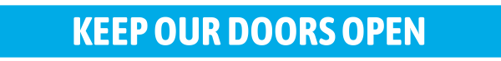
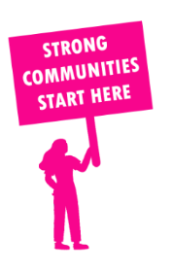
THE VALUE OF NEIGHBOURHOOD HOUSES IN MURRAY PLAINS IN 2024

Neighbourhood Houses are the Hearts of their Communities.
32,112 visits
367 volunteers
275 jobs
Value to the electorate
per $1 of income:
$2.04
Community value provided:
$14,578,857
Here’s what participants reported:
91% said the activity they participated in had a positive or very positive impact on their emotional wellbeing,
92% said the activity they participated in had a positive or very positive impact on their physical wellbeing
90% said the activity they participated in had a positive or very positive impact on their social connections.
62% participants became more involved in community activities outside of a Neighbourhood House
81% said the activity they participated in had a positive or very positive impact on their sense of belonging.

81
community groups supported
8,329
Sessions across 12 Neighbourhood Houses
115,200 KGS
in food relief
25.8
NHCP funded hours/week on average
2,196
Hours connecting people to gov services

Neighbourhood Houses in Murray Plains
Boort Resource and Information Centre
Cohuna Neighbourhood House
Crossenvale Community House
Echuca Neighbourhood House
Kerang & District Community Centre
Kyabram Community & Learning Centre
Lockington District Business Centre
Pyramid Hill Neighbourhood House
Quambatook Community Resource Centre
Rochester Community House
Swan Hill Neighbourhood House
Tongala Community Activities Centre
Aldara Yenara Aboriginal Corporation (Unfunded)

