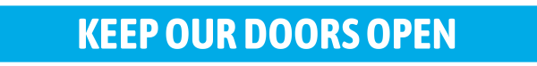
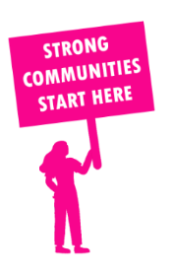
THE VALUE OF NEIGHBOURHOOD HOUSES IN GIPPSLAND EAST IN 2024

Neighbourhood Houses are the Hearts of their Communities.
30,300 visits
705 volunteers
565 jobs
Value to the electorate
per $1 of income:
$2.77
Community value provided:
$20,239,248
Here’s what participants reported:
98% said the activity they participated in had a positive or very positive impact on their emotional wellbeing,
98% said the activity they participated in had a positive or very positive impact on their physical wellbeing
97% said the activity they participated in had a positive or very positive impact on their social connections.
60% participants became more involved in community activities outside of a Neighbourhood House
82% said the activity they participated in had a positive or very positive impact on their sense of belonging.

96
community groups supported
8,849
Sessions across 19 Neighbourhood Houses
308,640 KGS
in food relief
24.2
NHCP funded hours/week on average
2,112
Hours connecting people to gov services

Neighbourhood Houses in Gippsland East
Bairnsdale Neighbourhood House
Bemm River District Neighbourhood House
Benambra Neighbourhood House
Bendoc Resource Centre and Neighbourhood House
Briagolong Community House
Bruthen and District Neighbourhood House
Buchan Neighbourhood House
Cann River Community Centre
Community Centre Swifts Creek
East Bairnsdale Community Hub
Heyfield Community Resource Centre
Lakes Entrance Neighbourhood House
Maffra Neighbourhood House
Mallacoota District Health & Support Service Neighbourhood House
Orbost Neighbourhood House
Paynesville Neighbourhood Centre
Segue Community Hub and Arts Cafe
Tubbut Neighbourhood House
Dargo Community House
Omeo Community Hub (Unfunded)

