
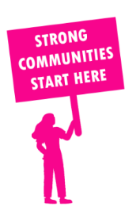
THE VALUE OF NEIGHBOURHOOD HOUSES IN BRIGHTON IN 2024

Neighbourhood Houses are the Hearts of their Communities.
21,948 visits
75 volunteers
46 jobs
Value to the electorate
per $1 of income:
$4.72
Community value provided:
$5,291,375
Here’s what participants reported:
91% said the activity they participated in had a positive or very positive impact on their emotional wellbeing,
98% said the activity they participated in had a positive or very positive impact on their physical wellbeing
95% said the activity they participated in had a positive or very positive impact on their social connections.
62% participants became more involved in community activities outside of a Neighbourhood House
80% said the activity they participated in had a positive or very positive impact on their sense of belonging.

30
community groups supported
3,714
Sessions across 3 Neighbourhood Houses
1,152 KGS
in food relief
25
NHCP funded hours/week on average
1,476
Hours connecting people to gov services

Neighbourhood Houses in Brighton
Castlefield Community Centre
Elwood St Kilda Neighbourhood Learning Centre
Hampton Community Centre

