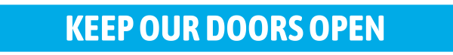
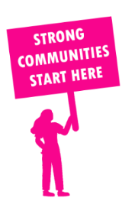
THE VALUE OF NEIGHBOURHOOD HOUSES IN MELTON IN 2024

Neighbourhood Houses are the Hearts of their Communities.
21,756 visits
77 volunteers
62 jobs
Value to the electorate
per $1 of income:
$0.75
Community value provided:
$19,993,025
Here’s what participants reported:
95% said the activity they participated in had a positive or very positive impact on their emotional wellbeing,
95% said the activity they participated in had a positive or very positive impact on their physical wellbeing
96% said the activity they participated in had a positive or very positive impact on their social connections.
65% participants became more involved in community activities outside of a Neighbourhood House
78% said the activity they participated in had a positive or very positive impact on their sense of belonging.

17
community groups supported
5,734
Sessions across 3 Neighbourhood Houses
128,940 KGS
in food relief
30
NHCP funded hours/week on average
228
Hours connecting people to gov services

Neighbourhood Houses in Melton
Djerriwarrh Community and Education Services
Eynesbury Discovery Centre
Kirrip Aboriginal Corporation
Melton South Community Centre

