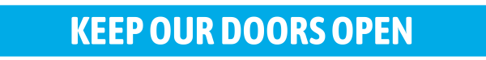
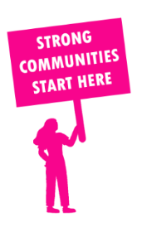
THE VALUE OF NEIGHBOURHOOD HOUSES IN RIPON IN 2024

Neighbourhood Houses are the Hearts of their Communities.
29,952 visits
324 volunteers
247 jobs
Value to the electorate
per $1 of income:
$3.98
Community value provided:
$10,361,123
Here’s what participants reported:
91% said the activity they participated in had a positive or very positive impact on their emotional wellbeing,
95% said the activity they participated in had a positive or very positive impact on their physical wellbeing
94% said the activity they participated in had a positive or very positive impact on their social connections.
62% participants became more involved in community activities outside of a Neighbourhood House
83% said the activity they participated in had a positive or very positive impact on their sense of belonging.

120
community groups supported
6,843
Sessions across 11 Neighbourhood Houses
81,996 KGS
in food relief
26.4
NHCP funded hours/week on average
2,196
Hours connecting people to gov services

Neighbourhood Houses in Ripon
Ararat Neighbourhood House
Beaufort Community House & Learning Centre
Clunes Neighbourhood House
Creswick Neighbourhood Centre
Dunolly & District Neighbourhood Centre
Haddon Community Learning Centre
Inglewood Community Neighbourhood House
Maryborough Community House
Mill House Neighbourhood House
St Arnaud Neighbourhood House
Wedderburn Community House

